Dear Year 6s,
Over the summer holidays, we would like you to complete the following four activities to help us get to know you really well when you join the school in the Autumn and to help you get to know us well too. Have a great Summer!
Mrs Vaz (Head of Year 7)
- Complete the following questionnaire and bring your completed version with you on the first day of school.
My name is:
The Primary School I attended is:
My favourite thing in the whole world is:
I live with:
The funniest person in my house is..
If I was going to meet the Queen I would wear...

I am very proud of the fact that this year I managed to/learnt to ....
My top three qualities are:
I enjoy...
I don’t enjoy...

When I move to Wallington High School
I am a little worried about ...
Or
One thing I don’t want to happen is...

When I move to Wallington High School
I am really looking forward to...
I can’t wait to...
Or
I would like to get involved with...

- Art Challenge: Using some of the answers from your completed questionnaire and/or anything else you would like to let us know about yourselves, create a painting or collage that represents you – your interests, beliefs, qualities and characteristics. Use your favourite colours and make it unique to you! The sky’s the limit in terms of your creativity but remember – you have to be able to bring it to school on the first day of term, so A4 – A3 size would be best!

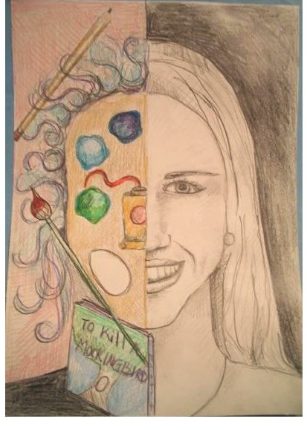

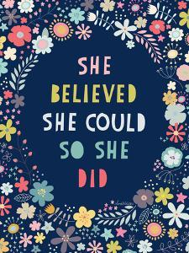
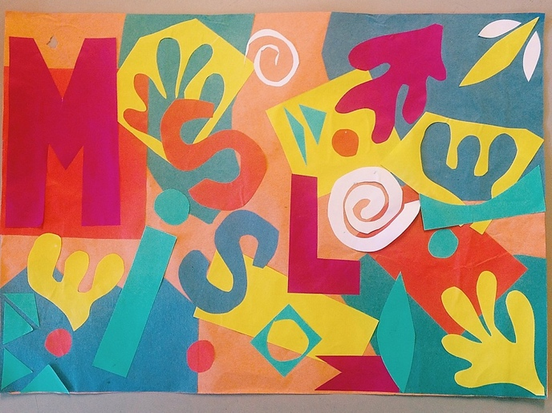

- Reading Challenge: Reading is an incredibly important aspect of your education – it makes you more knowledgeable about the world and more empathetic to the people in it.
Reading novels is one of life’s great pleasures. During Year 7, we expect you to spend at least 20 minutes each day reading a novel – this roughly equates to a new novel each fortnight.
Therefore, over the 6 weeks of the Summer Holidays, we’d like you to read 3 x new novels. You may have some books at home which you’ve been meaning to read – now’s the time! Alternatively, public libraries should be opening over the holidays or there are some great offers on Amazon.
Here are some websites to get you thinking about what you’d like to read. Choose something which interests you and you’ll be away:
https://carnegiegreenaway.org.uk/cilip-carnegie-medal-shortlist-2020/

https://www.penguin.co.uk/articles/children/2019/apr/must-read-books-for-9-12-year-olds.html

https://www.booktrust.org.uk/booklists/1/100-best-books-9-11/
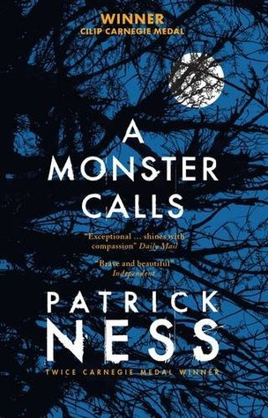
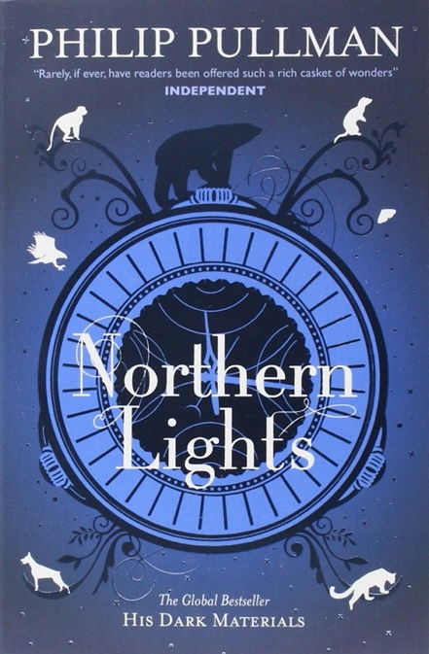
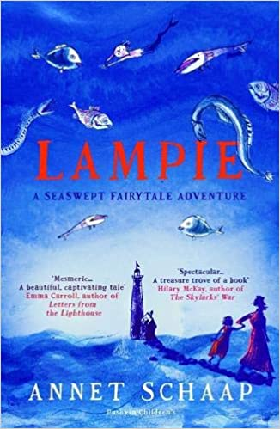

4.) The ‘Getting to Know Your New School’ Challenge!
Read through your copy of ‘Moving Up’ magazine, read/watch all of the resources that we’ve made for you on the ‘Transition’ section of our website and have a look at other areas of the school website to familiarize yourself with secondary school life at WHSG.
Once you’ve done your research, complete the following grid:

Questions: | Answers:
Full Name of the school
History and age of the school

School Address

School Telephone Number
Name of the Head Teacher
School starts at:
School ends at:
How long will it take you to get to school?
What time will you have to leave home in the morning?
What was our school play in Feb 2020?
Name one of the events or trips that run each year.

Add 10 words around this image to describe your new school.
